TSDR – Traffic Sign Detection And Recognition



Progress Report

submitted in partial fulfillment of the requirements for the degree of

**Bachelor of Technology**

in

**Computer Science and Engineering**

by

**Kartik Jain 1716110091**

**Mayank Sinha 1716110114**

**Mayank Vats 1716110115**

**Eraa 1716110070**

Under the Esteemed Guidance of

**Dr. Pramod Sethy**

**Krishna Engineering College, Ghaziabad- 201007 Affiliated to**

**Dr. A.P.J. Abdul Kalam Technical University, Lucknow**

**Table of Contents**

|  |  |  |
| --- | --- | --- |
| **S. No.** | **Topic** | **Page No.** |
| 1 | Abstract | 3 |
| 2 | Introduction | 3 |
| 3 | Detection | 4 |
| 4 | Recognition | 5 |
| 5 | Graphical User Interface | 6 |
| 6 | Progress | 9 |
| 7 | Summary | 10 |

1. **ABSTRACT**

The world is evolving every day, as the people are continuously working to make things simpler and simpler by automating them and one of such tasks is the Advanced Driver Assistance System (ADAS).  The application of ADAS is ‘Traffic Sign Detection and Recognition” (TSDR). TSDR is the system in which traffic signs are automatically detected and recognized. It plays a crucial role for the one who is driving the vehicle. As the driver needs to stay focused on the road while driving, the drivers might miss some of the road signs which can be dangerous for the driver of the vehicle as well as for other drivers. The TSDR will reduce this risk by automatically detecting the road sign using Computer Vision and machine learning algorithms such as Convolutional Neural Network (CNN) as  well as recognizing them. This whole process will reduce human efforts and the machine will accurately detect the sign without any human error.

1. **Introduction**

Traffic Signs are the road facilities provided to warn, inform, guide or restrict the driver from getting into any kind of accident. But keeping an eye on the traffic signs is not the only task of the driver, they need to focus on the road to prevent accident from other vehicles, keeping balance of their own vehicle and while carrying out such task it may happen that the driver might miss the traffic sign, or may be if he sees the traffic sign but doesn’t understand what this sign indicate, which might be dangerous for the everyone on the road.

So, for problems like this Advance Driver Assistance Systems comes into the play. Its application TSDR, can prevent many accidents by detecting the traffic sign by capturing the images from the cameras and informing the driver about the same. This will not only minimize the accident-rate over the road but also allows the drivers to drive with ease as they no more need to check for traffic Sign.

ADAS will become the future of automobiles, as the advancement in automobile technology in the industry is increasing what cars can do.

The proposed system here works in 3 phases:-

* Detection
* Recognition
* Graphical User Interface

1. **Detection Phase**

This is the 1st phase of our proposed system, in which we have to find the Traffic Sign Board out from a picture. This is very crucial phase as the recognition phase is depended upon the Detection Phase.

# The Detection phase is itself divided into 2 other phases:-

# Color Detection

# Shape Detection

# We have completed the 1st phase i.e. Color Detection and are still working on the Shape Detection.

# 

# The image will be sent to the recognition phase from here.

# Output:-

# C:\Users\Ankur Jain\Pictures\Screenshots\Screenshot (13).png C:\Users\Ankur Jain\Pictures\Screenshots\Screenshot (20).png

# C:\Users\Ankur Jain\Desktop\signs\images (11).jpgC:\Users\Ankur Jain\Pictures\Screenshots\Screenshot (35).png

1. **Recognition Phase**

This is the 2nd phase of our proposed system, in which we have to find the representation or meaning of the Traffic Sign Board from a picture passed from the detection phase.

For this part, we trained our model to recognize the German Traffic Sign Boards, and with the help of python libraries such as tensorflow and keras we are able to produce the accuracy of 92%.

# https://lh6.googleusercontent.com/WHHJJ09hjUgFJV9djIOmOOWRDePGY73J3oDVG00lmEaT4rrOs_i9boB0uXYkmCClfyDkUlC1Yf-yEScAhI6oytDFY-62OxuGFnT93tewSro233DEsXF2g2b2JflcAWecyA_X1XJruKY https://lh3.googleusercontent.com/YYLEsYq52-l1DnDFMxbFWsHIRvdC1HvcXC60MfU6BADyVqXwPWg8XjjSgBzwCGKxyb2zA7AaBEK1GRyP5S5-co5x3DvtYQTGwrCNKQkLPUlSI-KsiTnXQ5Dmjcxw8udvDxn41G7MxvI

# Output:-

# 

1. **Graphical User Interface**

This is the 3rd phase of our proposed system, in which user can interact with the system. As what will be the use of the software without an Interface, as no would be able to interact.

This part combines the knowledge of the Detection Phase and Recognition Phase, to present them to the user.

We have tried to keep this part as simple as possible, not added any unnecessary additional functions. With this UI, user can easily interact with the images to get the result.

This interface is currently limited to some particular types of images and not meant for every type of image, as we are still working on it, we will come with solution for this very soon.

# Output:-

**Step:-1** Click on Upload an image.

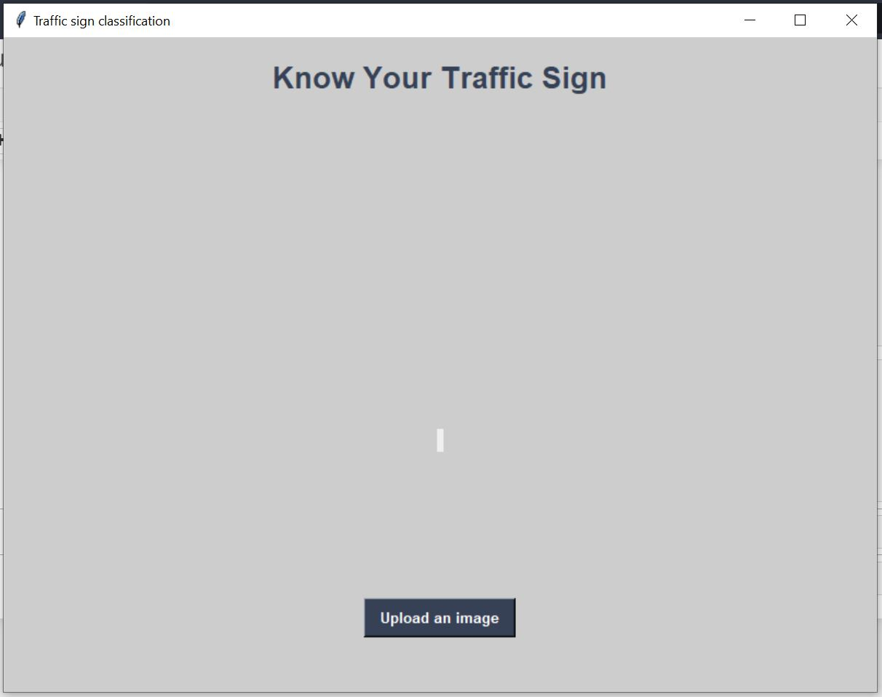

**Step:-2** Navigate to image location and click open after selecting the image.

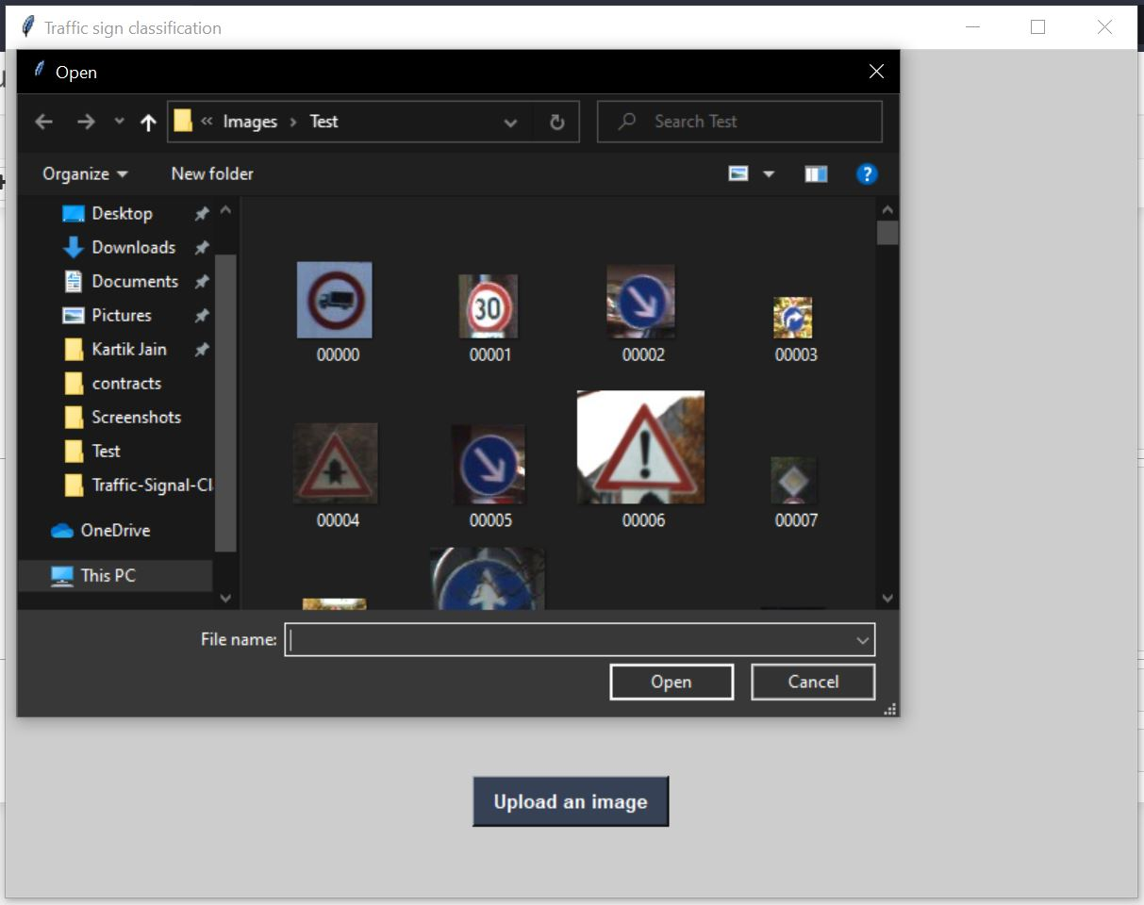

After Clicking Open your image will be loaded on the Interface and it will look like this.

P.S:- After uploading **Classify Image** button is enabled, which was disabled by default.

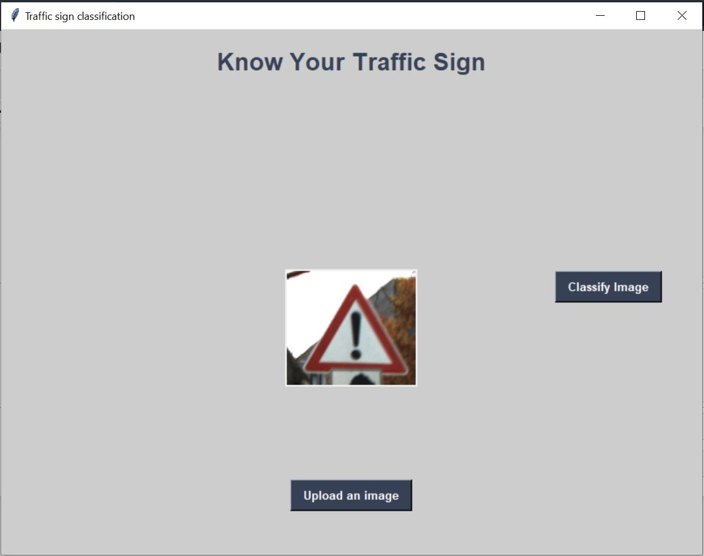

**Step:-3** Click on Classify Image, and the output (model prediction) will be generated.

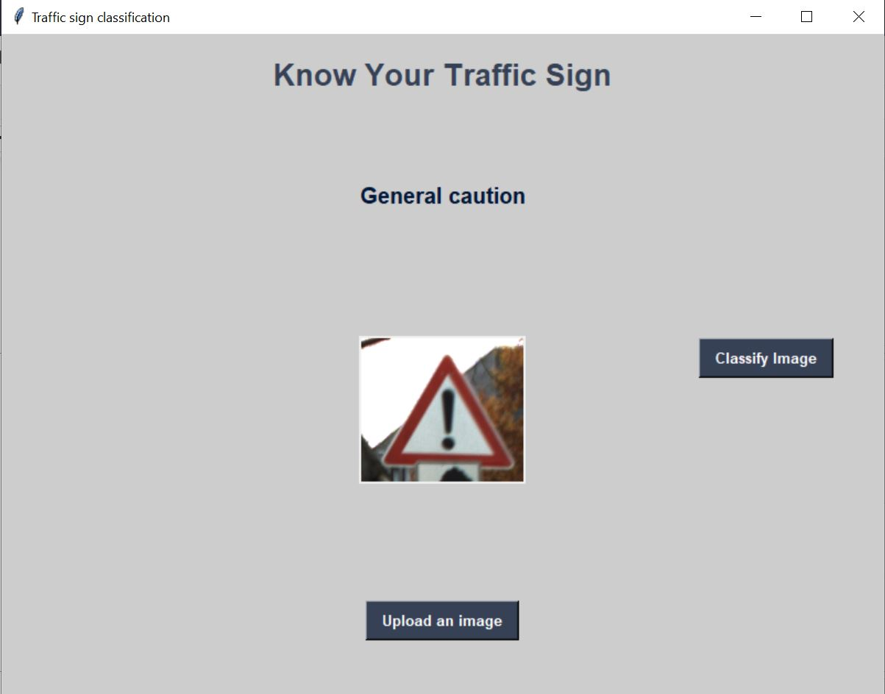

# Overall Progress

# 